To:

Dear:

We are pleased to inform you that you have been accepted at Hogwarts School of Witchcraft and Wizardry. Please find enclosed a list of all necessary books and equipment.

Term begins on September 1. We await your owl by no later than July 31.

Yours sincerely,

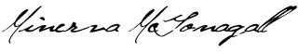

Miverva McGonagall
Deputy Headmistress

Hogwarts School of Witchcraft and Wizardry

Headmaster Albus Dumbledore
(Order of Merlin, First Class, Grand Sorc., Chf. Warlock,
Supreme Mugwump, International Confed. of Wizards)

